Indicative Critical Component List
Cell (IS 16046)
( Part-1 for Nickel System / Part-2 for Lithium System )

Details of Critical Components used: Model Name (Specify) :

Object/Part No. | Manufacturer/  Trademark | Type/Model | Technical Data | Standard | Mark(s) of  Conformity | Report no.
Positive
Electrode
Negative
Electrode
Electrolyte
Separator
Positive Tab
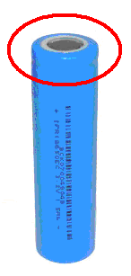
Negative Tab
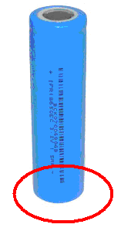

Required Documents for Testing -

1) Sample with proper marking label (Forty samples for every lead model)
2) Circuit Diagram
3) PCB Layout
4) Charging & Discharging Specification
5) ISO Certificate
6) Instruction & Service Manual
7) UN 38.3 Test Report
8) Packing Drawing
9) Safety Instruction and Disposal Plan
10) Business License (Copy of Original + English Translated) [Skip it if you have given it for any previous model]
11) Trade Mark Certificate (Copy) [Skip it if you have given it for any previous model]
12) If Series inclusion then Declaration letter from the manufacturer.

